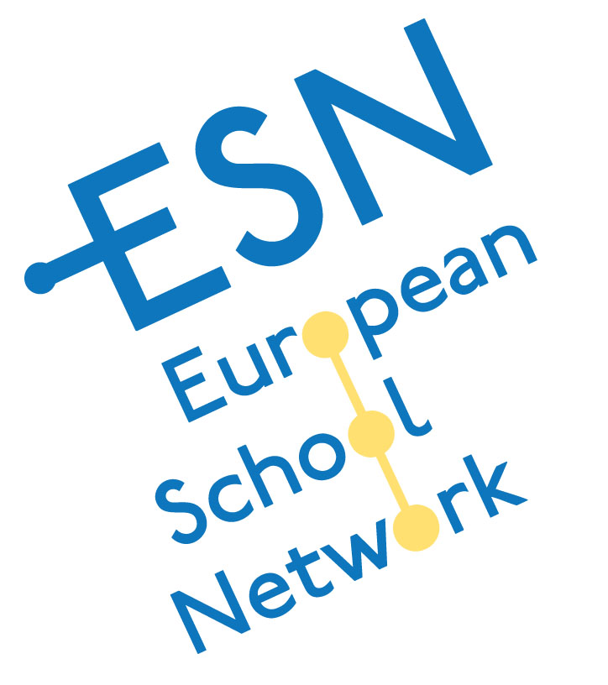EUROPEAN SCHOOL NETWORK
THE 4TH STUDENT SEMINAR
“SCIENCE and TECHNOLOGY EXCHANGE PROJECT FAIR”
ISTANBUL, TURKEY 29 April – 03 May 2014
12.05.2014

EUROPEAN SCHOOL NETWORK The 4th STUDENT SEMINAR ”SCIENCE and TECHNOLOGY EXCHANGE PROJECT FAIR” was held at ISTEK BELDE Schools in İstanbul- Turkey between 29 April – 03 May 2014.
18 students with 9 projects from 5 different schools from 3 countries attended the Student Seminar in Istanbul.
One of the major aims for this seminar was to provide students an international forum to exchange information about their own projects which solves a certain science or environmental problem which concerns humanity and the community.
Also other objectives were to:
- Provide an inspiring, open and safe environment for friendship between schools and students from all over Europe,
- Increase mutual understanding in order to improve the quality of our schools and sustain peace and welfare in Europe,
- Provide an opportunity for seminar participants to meet with people from other cultures and history.
A small project booklet has been published and distributed to all participators. Thus, students followed the Project Presentations more easily.
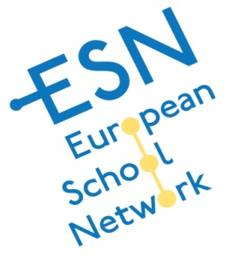Projects evaluated and ranked according to given criteria by teachers. Project assessment ranking has been done as first, second and third. The Certificates of Excellence and Participation distributed in the evaluation meeting. The memory plaques are given in the closing ceremony where all participators attended to the 7th Science Fair in Istanbul.

CONCLUSION:
The fourth ESN Science and Technology Student Seminar passed very quickly which was exciting, interesting and full of science. All students who attended the student seminar present their projects to all peers, visiting teachers and the jury with a great enthusiasm. All projects were discussed and detail was given to the audience and the jury after the project presentations. The jury constituted from the attending advisors and evaluated carefully.
After evaluations are done; first, second and third degrees have been ranked as;
- GERMANY/Zülpich Franken-Gymnasium
A day in the life of your heart
Franziska Theiß - Moritz Wallraff / Til Kreuels
- TURKEY/ İstanbul İSTEK ATANUR OĞUZ OKULLARI
Save villages from fire by the power of chemistry
Nurcem Öykü Aydın - Furkan Gülle / Sedat Çakaloğlu
- GERMANY/ CARL von OSSIETZKY SCHULE
Our personal boat
Clara Liebmann - Kirsten Meyer / Anna-Maria Frey

We wish to warmly thank all participants who provided us with their best efforts to make the seminar successful and reach the goals of ESN and also for their valuable contribution to the student seminar.
We will be looking forward to the fourth student seminar between 4 – 9 May 2015 in Istanbul.
Sincerely.

Murat GENÇ
Belde Schools
ESN Science Fair Coordinator

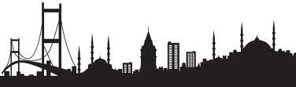EUROPEAN SCHOOL NETWORK
THE 4TH STUDENT SEMINAR
“SCIENCE and TECHNOLOGY EXCHANGE PROJECT FAIR”
April 28th to May 3rd, 2014 ISTANBUL, TURKEY
PROJECT FAIR ITINERARY
Days | Event | Event | Time | Place
April 28th Monday, 2014 | Arrivals | Arrival, meeting with host families, accommodation at host families and guest house | All day | Airport- School
April 29th Tuesday, | Opening  Settling of projects | Registration, Opening and  Introducing the project and participants  Fair Itinerary  School Orientation | 09:00- 11:00 | Auditorium
 | Excursion | Dolmabahçe Palace  Spice Bazaar | 11.00-16.00
 |  | Back to School | 16:00
April 30th Wednesday, | Oral Project Presentation Sessions  &  Display of Projects | Setling of projects | 08:30 - 08:50 | Auditorium
 |  | The choice of colours with reference to gender and preferences | 08:50- 09:10 | Auditorium
 |  | Fear | 09:10 - 09:30 | Auditorium
 |  | Our personal boat | 09:30 - 09:50 | Auditorium
 |  | A Hippie’s Dream | 09:50- 10:10 | Teacher's room
 |  | Coffee Break | 10:30 - 11:00 | Auditorium
 |  | Nature Science Association - Mimicry | 11:00 - 12:00 | Auditorium
 |  | Lunch at School | 12:00 – 12:45 | Cafeteria
 | City Tour | Basilica Cistern, Blue Mosque  Grand Bazaar, (Topkapi Palace* and Hagia Sophia*) | 12:45 – 18:00
 |  | Back home from Üsküdar or School | 18:00
May1th Thursday, | Oral Project Presentation Sessions  &  Display of Projects | A day in the life of your heart | 09:00- 09:20
 |  | Save villages from fire by the power of chemistry | 09:20 - 09:40 | Auditorium
 |  | Fragrances in Cosmetics | 09:40 - 10:00 | Auditorium
 |  | Coffee Break | 10:00-10:20
 |  | Zinc-air battery | 10:20 – 10:40 | Auditorium
 |  | Using Barium Borate Compounds in Paint Tecnology | 10:40-11:00
 | Excursion | Boat Tour through the Bosporus to Anadolu Kavağı with Host Families –Lunch on the boat | 11.00- 18:00
 |  | Back home from Üsküdar | 18.00
 |  | Dinner with guest teachers | 19:30 - 22:00
May 2nd Friday, |  | Art activity | 08:30 - 10:30 | Art Room
 |  | Science Presentation / Laboratory | 10:30 -11:30 | Physics Lab.
 |  | Evaluation meeting | 11.30-12.00 | Amfi
 |  | Lunch at School | 12.15-13.00 | Cafeteria
 |  | Service to Taksim to Galata -Karaköy | 15:40
 |  | Back home
May 3rd Saturday, |  | Opening ceremony of ISTEK BELDE SCHOOLS VII. SCIENCE COMPETITION | 09:30 -10:30 | Auditorium
 |  | Visiting Projects at Science Fair Exhibition Hall | 10:30 -13:00 | Exhibition Hall
 |  | Lunch | 13:00- 13:30 | Cafeteria
 |  | Free time | 13:30
May 4th Sunday, 2014 |  | Departure
*Optional

THE 4TH STUDENT SEMINAR
THE PROJECT LIST
No | Country/City | Name of the School | The Project Title | Name Surname
1 | HOLLAND / Leiden | HET VLIETLAND COLLEGE | Fear | Talitha Koopmans | Gijs van Eedenburg
2 |  | HET VLIETLAND COLLEGE | Fragrances in Cosmetics | Elvira Visser
3 |  |  |  | Emma Schouten
4 | GERMANY / Zülpich | FRANKEN GYMNASIUM | The choice of colours with reference to gender and preferences | Celine Lorraine Puritz | Til Kreuels
5 |  |  |  | Franka Thon
6 |  | FRANKEN GYMNASIUM | A day in the life of your heart | Franziska Theiß
7 |  |  |  | Moritz Wallraff
8 | GERMANY/ Wiesbaden | CARL von OSSIETZKY SCHULE | Our personal boat | Clara Liebmann | Anna-Maria Frey
9 |  |  |  | Kirsten Meyer
10 |  | CARL von OSSIETZKY SCHULE | Zinc-air battery | Hanna Liebmann
11 |  |  |  | Maria Derix
12 | TURKEY/ İstanbul | İSTEK ATANUR OĞUZ OKULLARI | Save villages from fire by the power of chemistry | Nurcem Öykü Aydın | Sedat Çakaloğlu
13 |  |  |  | Furkan Gülle
14 | TURKEY/ İstanbul | ISTEK BELDE OKULLARI | Using Barium Borate Compounds in Paint Tecnology | Berkay Yıldıran | Nur Yıldıran
15 |  |  |  | Ece Naz Barış
16 | TURKEY/ İstanbul | ISTEK BELDE OKULLARI | A Hippie’s Dream | Aslı Gürtekin | Benan Gülay
17 |  |  |  | Gamze Güner

SCIENCE & TECHNOLOGY EXCHANGE PROJECT FAIR
INSTRUCTION FOR PRESENTATIONS
Project presentations of international students will be held in 2 ways.
- Oral presentations:
Oral presentations will be on April 30th and May1th 2014. Talks will be in English. There will be 15 minutes available for each talk, plus 5 minutes for questions and discussions, making 20 minutes in all. Oral presentation rooms will be equipped with a computer and a data projector. All presentations must use “windows based” Microsoft PowerPoint® Software. Macintosh® Presentation software will not be available to the presenter. Presentations should be stored on a USB drive or on a CD. The Jury will evaluate the project during the presentation according to the given criteria.
- Poster Presentations:
Posters will be displayed at the Science Floor from April 29th to May 2nd and on 3th of May at the Science Fair Exhibition Hall. Jury can evaluate the poster any time during the fair.
Please note that your poster should be printed to fit appropriately on the poster board. Project printing is not available at the school. Each poster presenter will be provided with a display surface to mount their poster presentation, as well as pushpins (see application form). Poster materials should be legible from a distance of two meters. Lettering in text and figures should be at least 5 mm, and the heading should be at least 10 mm. The title of the project, the authors and their affiliations should appear near the top of the poster in letters approximately 25 mm.
Remarks:
Posters’ title, authors and institutions of origin in large letters should be displayed at the top of the poster. The background information, hypothesis, aims, material and methods, results and conclusions should follow. You should also list your references.
You should prepare an oral summary of the important points in the project which you can present in no more than 60 seconds. Each member of the group should be fully knowledgeable about the project and be prepared to discuss his/her part.
Jury is going to be constituted among the advisors.
Jury is going to evaluate each project during the oral presentation except their project.

