Our Project Week 2014: Let’s Celebrate

On January 19th, a late Sunday evening, we waited for our exchange students at the train station in Frankfurt. Five students from Hungary, three boys and two girls, and a girl from Finland spent one week in Germany to learn about our culture and festivals during our school project week. Weeks before this day we decided to choose this project and our teacher Ms. Meireis contacted different schools in different countries through ESN. The whole class started to plan the week and made groups, which had different things to do. On Monday the exchange students had to spent the day in the regular lessons because our project week just started on Tuesday. On Monday afternoon we made a tour through Wiesbaden with the most important places like the Landtag, the Marktkirche and the big cuckoo clock and our different hot springs. The whole topic for our project week was festivals in our countries: Germany, Hungary and Finland. We had prepared presentations about 'carnival' and the main topics of it. We presented them at Tuesday, as well as the Hungarian students and the Finnish student. We also ate typical foods and for example threw candy like in the German carnival parades. The students from our class, who didn't do a presentation, prepared a tour. One was to Mainz on Wednesday. We went to the Mainzer Dom (cathedral) and to the Stephans Church with the famous windows by the Jewish artist Marc Chagall, as well as to the Rhine shore. Our last station was the Faschingsmuseum (carnival museum) where we did a quiz and spent a good time. After that we could spent some more time in Mainz on our own. In the afternoon the students with an exchange partner spent some more time together watching a movie. On Thursday we had a second tour. It lead us to Frankfurt. We saw the Hauptwache, the Römer, Goethe’s house and the Paulskirche. We had to travel a lot with the tube. At the end we ate real 'Frankfurter currywurst'. After that we had, again, time on our own, which most of us spent shopping for clothes and souvenirs. Both teams from the tours, were well prepared, and could tell us much about the things they showed us. On Friday the only thing we had to do was prepare our presentations, like posters and pictures, for Saturday, when our school had an open house day. For Saturday we also made Krapfen (some sweet fried pastry) by ourselves and decorated the room like it is used to look on carnival. Friday evening we went to the 'fun factory' where we ate and later played bowling, it was a lot of fun and a good alternative to the stressful tours and really relaxing. Saturday morning we gathered all together in our class room to plan the day. We made groups when who has to be in the room and show and present our projects to the visitors. We stayed till 2 pm and then we had the day to ourselves again. This was the official end of our project week and we got certificates, but for the students with an exchange partner the week went on. We met again in the evening to spent more time together on our last evening. Sunday, early in the morning, only 4 am, we had to return to the train station in Frankfurt, because the train for the Hungarians left that early in the morning. Kirsi from Finland had already travelled back to her country, by plane, on Saturday. We did not like to part with our guests, but all of us were happy to be in bed again soon. The week was really interesting and exciting but also exhausting. It was an experience that everyone should make in their life if they have the chance. We learned a lot about foreign countries and their different cultures. We all will be happy to see and visit our exchange partners again.

Kira Löffler

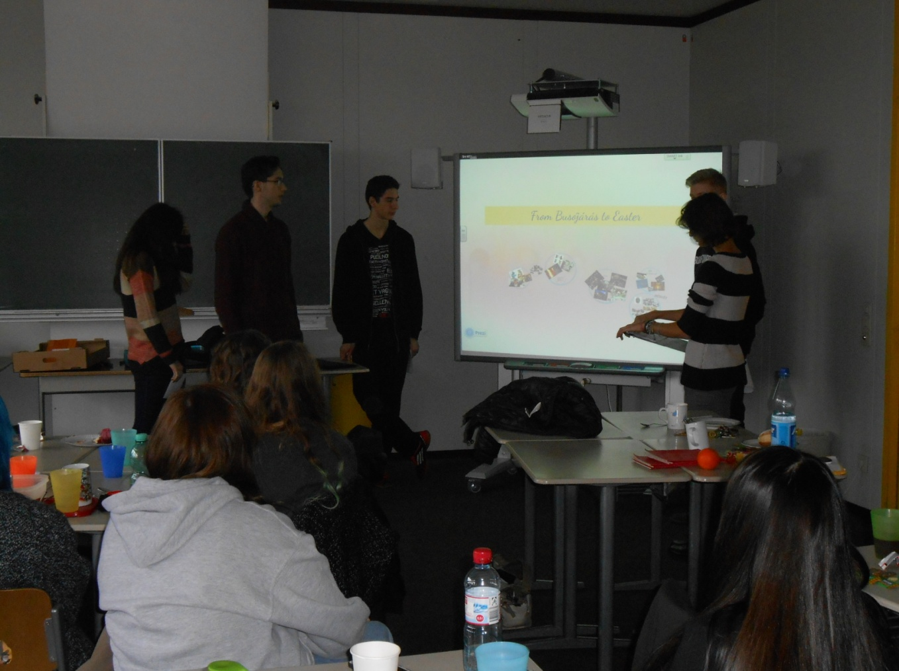

Garbo, Iggi, Ezster, Gabriella and Adam presenting the time from Busójárás to Eeaster.

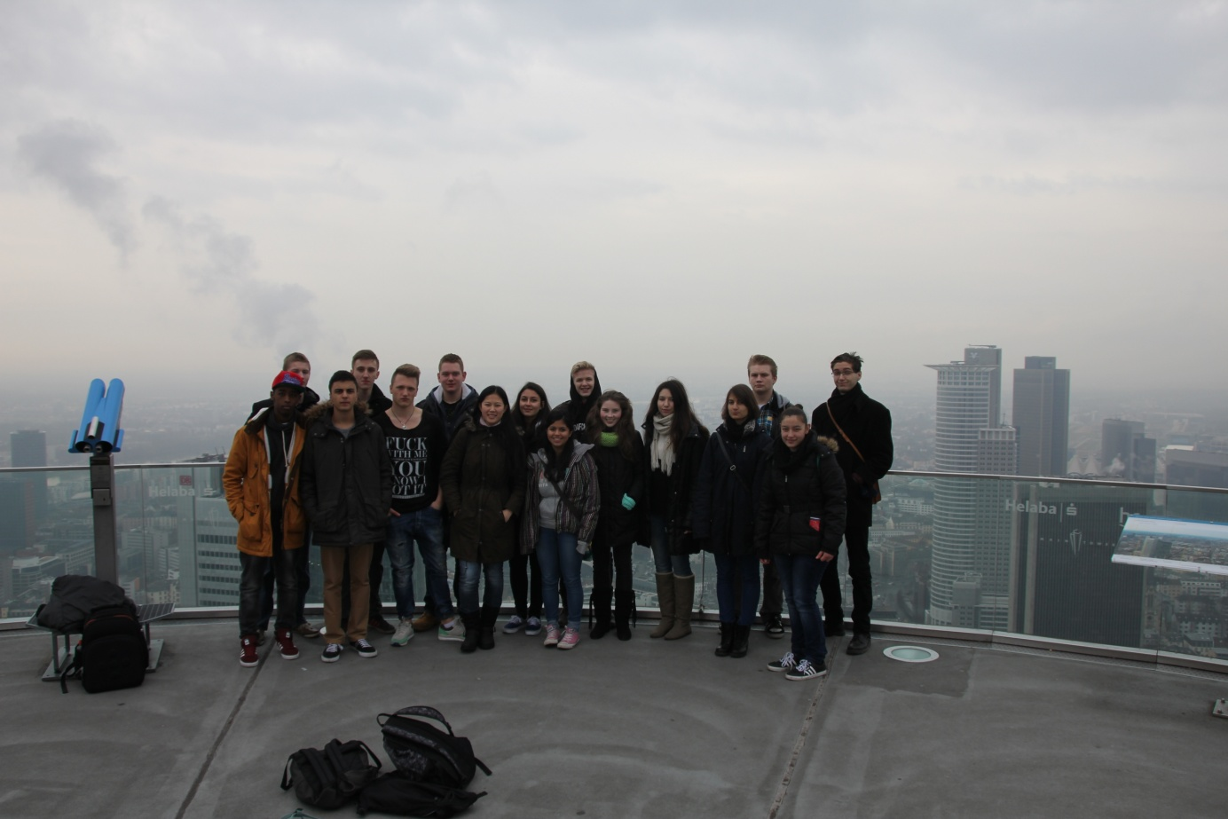
On the Maintower
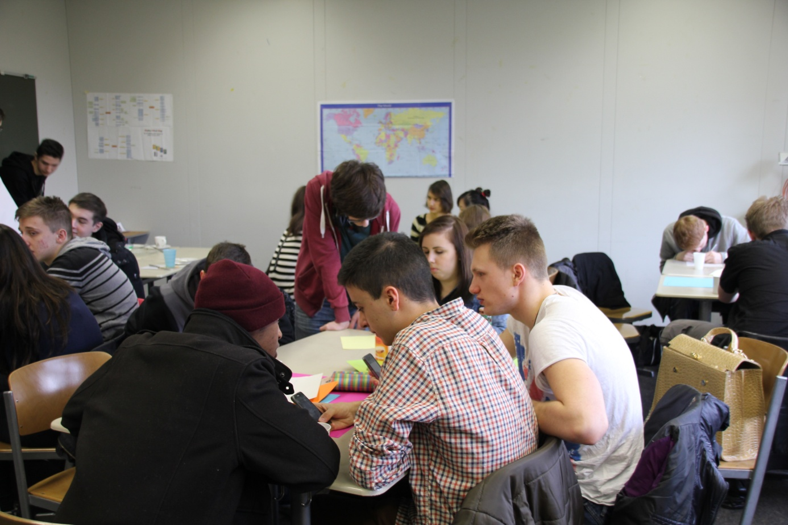
Everyone is working hard on their presentations :)

