
Exchange 2012
Eline van der Schaar
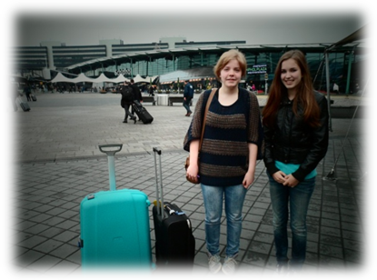


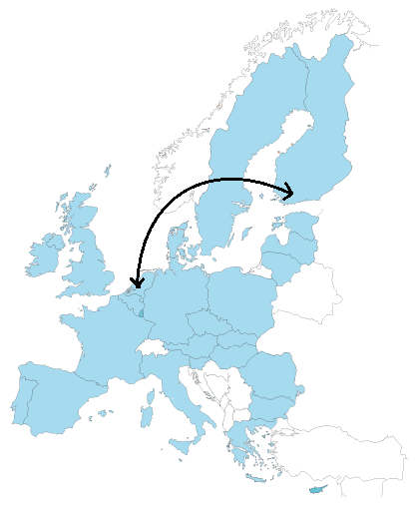
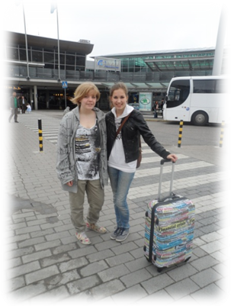

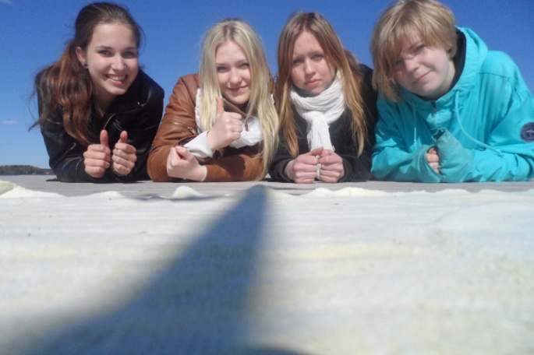
I left on 09-05-’12 on my own to Finland for my exchange with Maiju. When I arrived there, Maiju and her mother and brother picked me up from Helsinki airport. I wasn’t that shy, but I think that’s because I already knew Maiju. I think it was much harder for her when she was in Holland a few weeks ago.
Everything was so new and strange for me, but it was so cool to see how different the culture is from mine.
In the beginning I was a little bit scared to speak English, because I didn’t want to say something wrong. Later I just didn’t care anymore.
The first days at school where amazing. It was interesting to see how everything works. The lessons where so quiet and the students are more serious than in Holland. It was also strange that they get awarm lunch at school at 11 ‘o clock in the morning. The food wasn’t that different but of course there were some different products.
I liked the houses in Finland. The most houses have just one floor. It felt like you are spending much more time together. Maiju’s friends were very kind and they always tried to speak English when I was around.
I went together with Maiju’s friends to a little sauna at a lake. There I jumped in the ice cold water after the sauna. It was good and awful at the same time :)
We did a lot together with her friends, it was so much fun! I am absolutely sure that I have some new good friends!
The family was very kind and nice to me, I felt very welcome.
The lakes were amazing to see. It was so cool to see that the lakes have different colors like blue, green and other shades. The nature was just beautiful and so quiet.
It was weird to see that there are almost no lights next to a roads. It became very dark late in the evening.
It was a very nice experience and I can’t think about another exchange partner then Maiju.
If I could go back to Finland, I would absolutely go. 

