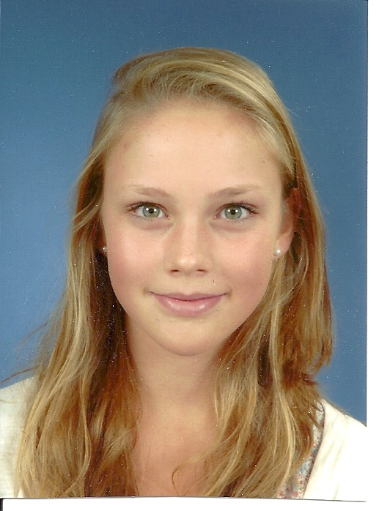

Eline Struik from Leiden had 10 amazing days in Finland, she will never forget this!

My name is Eline Struik, I'm a sixteen years old girl from Holland. I live in a city called Leiden. I attend school at 'Het Vlietlandcollege' and I'm in Higher General Secondary Education.

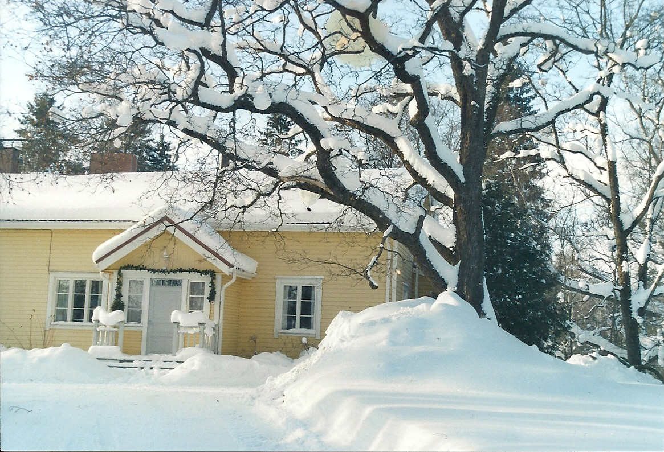
On the internet site of my school I read an essay about an ESN exchange with Finland from a girl from my school. I thought that would be an unforgettable experience. So I found on the ESN site two Finnish girls, called Elina and Elisa. I started mailing with them. We decided that I would go in February to Sahalathi in Finland and they would come in May to Holland.
I was a little afraid, because I had never travelled without my parents and I didn't know my host family very well. I had to transfer in Riga, Latvia. When I arrived in Tampere, Finland, it was very cold and everything was white. Timo (the father) and Elina (the girl with whom I stayed) picked me up with the car. Elina's house in Sahalahti was really cute, it was big, yellow and made of wood. They had a big garden with other buildings on it. And of course they had a sauna, I have been in it many times. I met her mother Anne and her little sisters Maria and Anna. And there were two cats, but I forgot the names. The family was very friendly. The first thing we did when I arrived was eating. They had made Finnish pizza. They eat so much in Finland. Breakfast (7 o'clock), Lunch (11 o'clock), dinner (5 o'clock) and another meal (10 o'clock). I slept in Elina's room . I felt really comfortable in the family, I could ask anything.


We have done so many things. We went shopping in Tampere a few times. I have been to the theater with Maria. We watched a play about a carnivorous plant. It was called Pieni kauhu kauppa, what means Little Shop of Horrors . I understood it, because there were a lot of songs and they acted very well! I have also been to the movie I Love You Phillip Morris with Elina. There were Finnish and Swedish subtitles. I concentrated me on the English spoken text. We went skiing one day. It was really funny. Elina and Anna were boarding. And I have tried cross country skiing. That is really impossible, with your skis going on a hill. I have done two big rounds, but in the same time another man skied like 10 rounds. I thought it would be cold in the evening, but during cross country skiing I felt so warm. In Finland ballroom dancing is popular. The first evening when I was in Finland, Elina showed me a video on which she was dancing. I saw a lot of couples dancing together in nice dresses. I went with Anne, Anna, Maria and Elina to the dancing school. I followed a lesson with different kinds of styles. I have also followed a jazz-ballet lesson with Elina. When Elina had to dance, Maria and I went to Grandmother who lived in the center of Tampere. The grandmother was so nice. She ordered some food for us and tried to talk with me. But she didn't speak English at all. But with her hands and some German and Swedish words we had a conversation. She told me about her husband who was an Olympic champion with gymnastics. We saw a documentary about the 70 years old grandfather who started again with gymnastics. It was really funny to see a 70 years old man making a somersault. We also saw X-factor in Finnish and a program about farmers who are looking for a girlfriend. Really funny, because both programs are also on the Dutch television. Another time we lunched with Grandmother and the whole family.
I have also been to a dancing night. It was special. There were really old men who chose young girls to dance with. I also met some of Elina's friends. Especially Elisa, Elina's best friend. We made a sightseeing tour by car, but the only thing I saw was snow, snow and snow. The windows were frozen...
We also had dinner in a restaurant with the whole family. I liked it! We went to a Spanish restaurant. I tried some Finnish food, like a kind of yoghurt with oatmeal or something on it. And ate a black sausage, with blood in it. I also tried something like rice with liver in it. I didn't like that food. The bread and butter in Finland were also different. The bread is darker and tougher than the Dutch bread, and the butter was much saltier. They don't have so much sweet like we have in Holland. But I really liked the apple juice and lemonade which they made of fruit out of the garden.
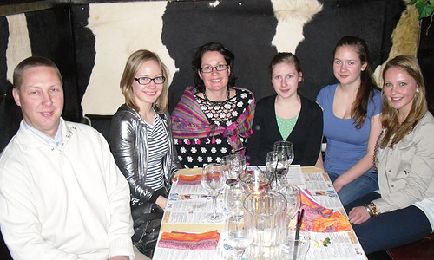Timo, Elina, Anne, Anna, Maria, Eline

And the last day I went with Anna to Helsinki. That was really funny. We had to go alone by train. Anna spoke a little bit English, but we were only laughing. Anne gave me a map with some buildings I had to see, but we only saw the parliamentary building and a lot of shopping malls! The weather was not so good, because the snow was melting.

We did not only do things like that. I also went to school. The school was in Kangasala and was called Kangasalan Iukio.
The school was really different from my school. There were only students of 16/17 years and older. And there were not so many students as in my school. The school started at a quarter past 8. I had to wake up very early, at six o'clock, every school day. We had to go by car to the bus stop and the bus drove us to school. The lessons are very long, 75 minutes. I liked the English and French lessons, because I could understand the lessons. I didn't like the lunch at 11 o'clock. For me it was too early, and I prefer my Dutch sandwich.

In May Elina & Elisa came to my house and to my school. We did a lot of nice things. Of course we went to The Hague, Amsterdam and the center of Leiden. They have also seen Naturalis, a natural history museum and Madame Tussauds. And we made a boat trip trough the canals of Amsterdam. They really wanted to see The Red Light District, they were in shock. The coffee shops were also shocking. We also went out one night.
Elisa and Elina thought my school was a little too big and they didn't like the many lessons a day. They really missed their warm supper. For them it is usual to have a break after each lesson, for us in Holland it isn't.

They told me they really like Holland, because people are not as shy as in Finland and distances are much shorter. In Holland we can do everything by bike. In Holland young people are much more independent.

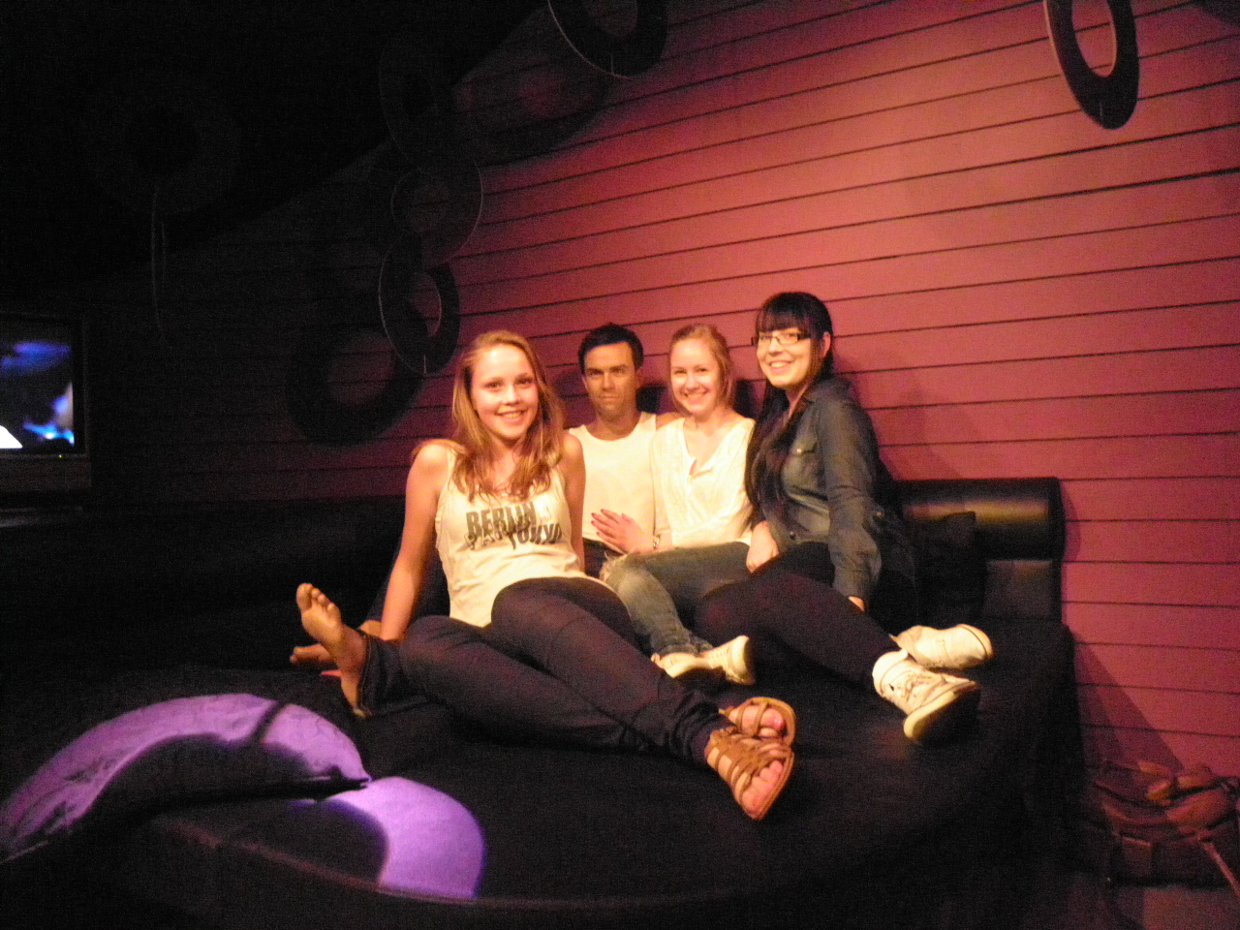Eline, Robbie Williams, Elina and Elisa in Madame Tussauds.
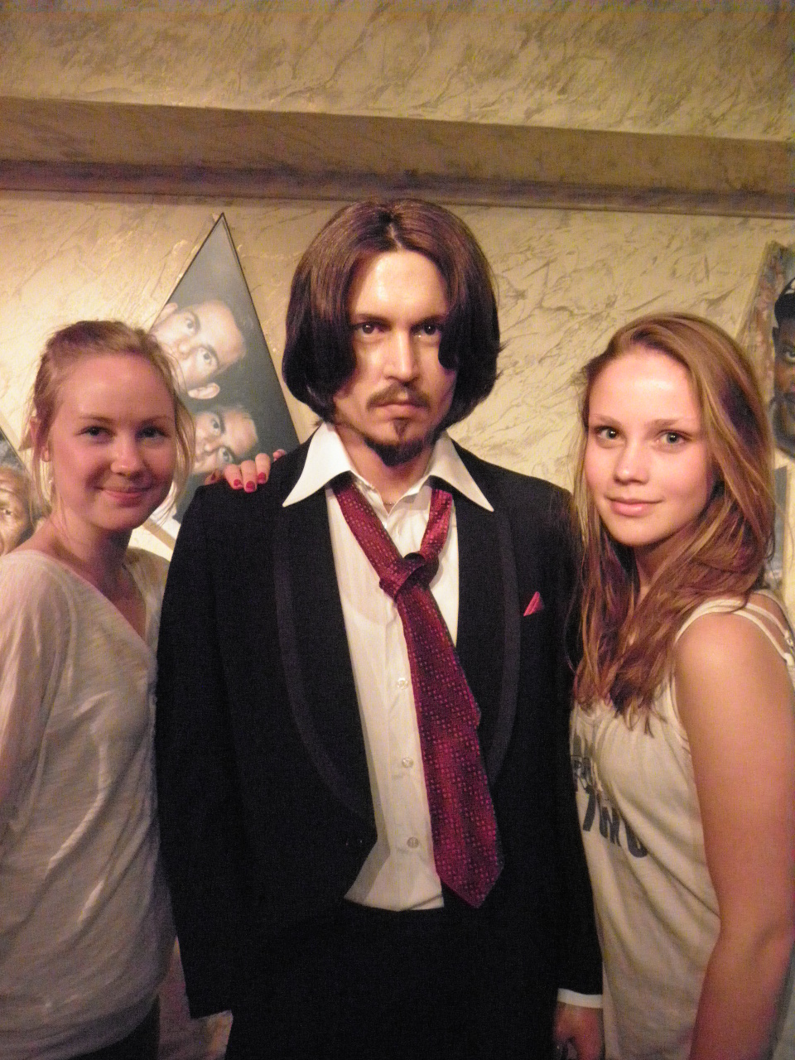
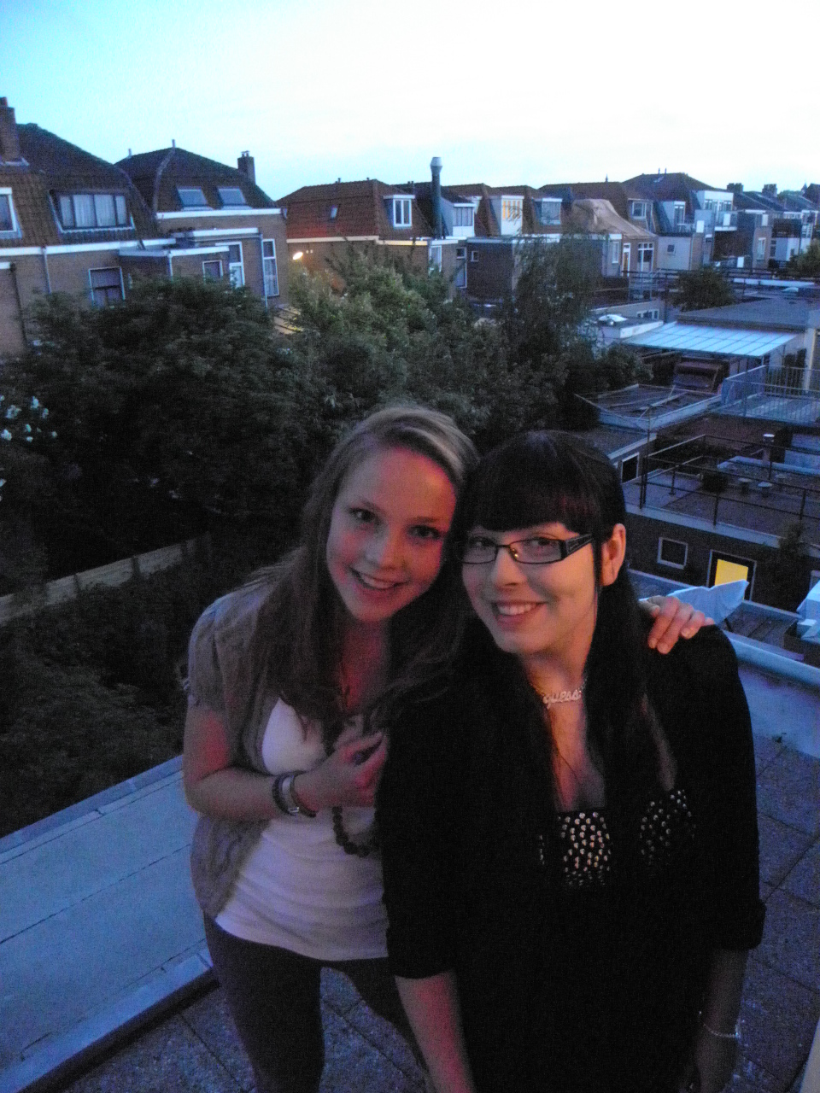

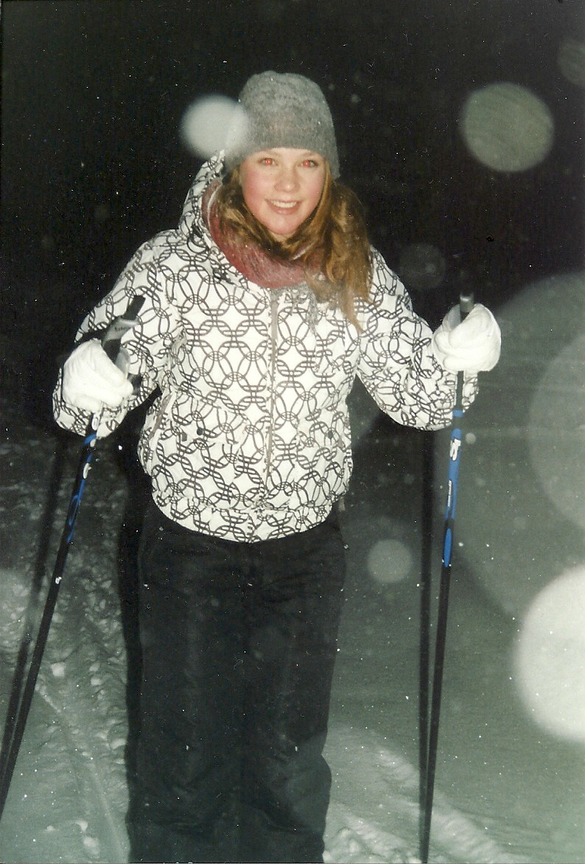
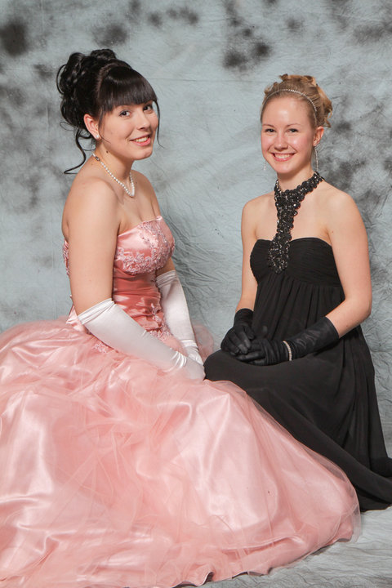

I really had a nice stay in Finland. The family did so many nice things with and for me. I really felt like a part of the family! They made me feel comfortable and gave me an unforgettable week. I'm really happy I met those people. I really recommend a trip like this!


